# FUTURE-PROOFING CONSTRUCTION: ESSENTIAL COMPETENCIES AND AI INTEGRATION IN PROJECT MANAGEMENT

# ABSTRACT

This research paper extends a preliminary analysis of job advertisements to delve deeper into the practical application and impact of skills and competencies in construction project management. The initial study identified key skills and competencies essential for effective leadership and management of construction projects, highlighting employer expectations for potential candidates. This follow-up study aims to evaluate how these identified skills are utilized in practice and their correlation with project success. Additionally, it examines the challenges project managers face in acquiring and implementing these competencies.

A key contribution of this research is the inclusion of political skills as one of the essential skills for construction project managers, alongside conceptual, human, and technical skills (CHPT construct). The research discusses the components that form each skill construct and explains why they are crucial for construction project managers' performance. By raising awareness of these essential skills, this research aims to help construction project managers enhance their effectiveness and improve project outcomes.

We analyzed data from two major surveys: one conducted by KPMG in 2023 and another by the Project Management Institute on job growth and talent gaps from 2017 to 2027. These surveys provided insights into the job talent gap, the role of artificial intelligence (AI) in enhancing project manager efficiency, and the impact of project manager skills on project success, national GDP, and future opportunities.

The paper is structured into three main sections: the first section covers the CHPT construct skills, explaining why each category is essential for construction project managers. The second section presents findings from the surveys, highlighting the job talent gap and the evolving skill requirements. The third section explores how AI can enhance the tasks of project managers, contributing to greater efficiency and effectiveness in project execution.

AI has significantly influenced project execution and the project manager's role. The PMI Talent Triangle® outlines essential knowledge and skill elements for developing project management competency, identified through a survey of construction industry project managers. This report seeks to answer the question: How can project management knowledge and skills be developed and implemented effectively in the construction industry? Our findings reveal that scheduling and planning management are crucial knowledge areas, while delegation, leadership, decision-making, and problem-solving are vital skills for construction processes. The project manager's role is pivotal for construction project success, necessitating a balance of management and technical skills. Consequently, construction project managers must enhance their personal knowledge management skills to develop and implement project management practices effectively.

Keywords: artificial intelligence (ai) integration, chpt construct, construction project management, essential skills and competencies, political skill.

**1**. **INTRODUCTION**

The Australian construction industry is currently navigating a complex landscape characterized by numerous challenges and rapid evolution. Factors such as globalization, fluctuating financing, environmental concerns, intense competition, and the continuous advancement of technology have created a dynamic and demanding environment for construction professionals. These challenges are compounded by heightened expectations from clients and stakeholders, who demand higher standards of efficiency, sustainability, and innovation in construction projects.

The PMI Pulse of the Profession report brought attention to the significant financial impact of poor project performance on organizations worldwide, revealing that inefficient project management practices led to a waste of US$122 billion for every US$1 billion spent on projects. Research indicates that organizations implementing formal project management methods can reduce financial wastage by a factor of 13 compared to those that do not utilize such practices (PMI, 2016). In the realm of construction, projects play a pivotal role in driving organizational objectives and enhancing profitability, necessitating a focus on efficient project completion strategies (Trebilcock, 2007). Project management within the construction sector serves to enhance project outcomes and streamline operational processes, requiring project managers equipped with the requisite expertise in project management techniques to ensure successful project delivery.

Construction organizations heavily depend on the competence of their project managers, necessitating not only experiential learning but also a comprehensive knowledge base for effective project management. Given the fierce competition in the marketplace, construction firms stand to gain by understanding the specific knowledge requirements and proficiency levels essential for construction project managers (Peterson, 2008).

One of the most pressing issues in the construction sector is the notable deficiency in soft skills among project managers. This deficiency has been highlighted in various academic studies, including those by Cooke-Davies (2002), Darnell (2005), Geoghegan & Dulewicz (2008), and Gido & Clements (2012). These studies emphasize that while technical skills are fundamental, the cultivation of soft skills is equally crucial for the success of construction projects. Soft skills such as communication, leadership, problem-solving, and emotional intelligence are essential for managing teams and stakeholders effectively. As the construction industry becomes more complex, the need for project managers to possess a balanced skill set of both technical and soft skills is increasingly recognized by both industry professionals and academic institutions.

The methodology selected for executing a construction project significantly influences its success or failure. Traditional project delivery methods are being challenged by evolving business conditions, new client requirements, and technological advancements. This shift necessitates project managers to be adaptable and innovative in their approach. The ability to integrate new methodologies and technologies while maintaining effective project management practices is vital for ensuring project success.

In this context, stakeholder management emerges as a critical component of project management. Project managers are not only responsible for the technical aspects of a project but also for fostering a collaborative environment among diverse stakeholders. This includes clients, contractors, team members, regulatory bodies, and the community. The competencies of project managers, therefore, serve as a crucial predictor of project success. Understanding and honing these essential skills and competencies are imperative for the successful execution of construction projects.

The scholarly focus on competencies in construction project management is well-documented. Numerous studies have identified key skills necessary for different types of projects, particularly in the construction sector. These competencies include technical skills, such as scheduling, budgeting, and quality control, as well as soft skills, like leadership, communication, and conflict resolution. The ability to manage and integrate these skills effectively determines the overall success of construction projects.

The theoretical foundation of this research paper is built upon the existing literature on project management competencies. Following this foundation, the paper presents a detailed description of the research methodology and findings. The results are discussed about previous research, highlighting new contributions to the field of construction project management.

The complexity of construction projects has increased significantly over the years. New regulations, environmental considerations, and health and safety requirements add layers of complexity that project managers must navigate. Each construction project is unique, with varying clients, team members, locations, contractors, and timelines. This uniqueness complicates the application of lessons learned from past projects to future endeavors. Additionally, the interdisciplinary nature of project teams requires project managers to lead and coordinate individuals from diverse backgrounds and with different objectives.

In this evolving landscape, the importance of effective project management cannot be overstated. Successful project management practices encompass a range of methodologies, software tools, knowledge areas, and skills that are essential for the initiation, planning, execution, monitoring, and control of construction projects. Knowledge management plays a critical role in managing change within projects. Project success is often measured by the degree to which stakeholder requirements are met. Numerous studies have shown that the competencies of project managers have a significant impact on project performance. Therefore, identifying and enhancing these competencies is crucial in today’s competitive market.

The **CHPT** (Conceptual, Human, Political, and Technical) construct of skills is particularly relevant in this context. Conceptual skills involve the ability to understand and integrate various aspects of the project, foresee potential issues, and develop strategies to address them. Human skills are essential for managing relationships within the project team and with external stakeholders. Political skills involve navigating organizational dynamics and building coalitions to support project objectives. Technical skills, while fundamental, must be complemented by these other skills to ensure comprehensive project management.

The first section of this paper delves into the CHPT construct, explaining the importance of each skill category and why they are essential for construction project managers. The second section presents findings from major surveys conducted by KPMG in 2023 and the Project Management Institute on job growth and talent gaps from 2017 to 2027. These surveys provide insights into the job talent gap and the evolving skill requirements. The third section explores how AI can augment the tasks of project managers, contributing to greater efficiency and effectiveness in project execution.

The Australian construction industry is at a pivotal point where the integration of new skills and competencies, along with the adoption of advanced technologies, can significantly influence its future trajectory. As construction projects become more intricate, the role of the project manager evolves to meet these new challenges. Effective project management now requires a blend of traditional skills and innovative approaches to navigate the complexities of modern construction projects successfully.

## 1.1 THE CHPT CONSTRUCT OF SKILLS

The CHPT constructs Conceptual, Human, Political, and technical skills that form the cornerstone of effective construction project management. Each category encompasses a set of competencies that are vital for navigating the multifaceted challenges of construction projects.

* **Conceptual Skills:** involve the ability to comprehend and synthesize various project elements, foresee potential challenges, and develop strategic solutions. These skills enable project managers to understand the broader context of a project, integrate different components effectively, and ensure that the project aligns with the overall business objectives. Conceptual skills are critical for planning, risk management, and decision-making processes.
* **Human Skills:** are essential for managing relationships within the project team and with external stakeholders. These skills include communication, leadership, motivation, and conflict resolution. Effective human skills enable project managers to build cohesive teams, foster collaboration, and maintain a positive work environment. These skills are particularly important in construction projects, where teamwork and stakeholder engagement are crucial for success.
* **Political Skills:** involve the ability to navigate organizational dynamics, build alliances, and secure support for project initiatives. These skills are essential for managing the complex web of relationships and power structures within and outside the organization. Political skills help project managers to advocate for their projects, negotiate resources, and manage stakeholder expectations. The inclusion of political skills as a critical competency highlights the importance of strategic thinking and influence in project management.
* **Technical Skills:** are the foundation of project management and include knowledge of construction processes, project planning, scheduling, budgeting, and quality control. While technical skills are fundamental, they must be complemented by conceptual, human, and political skills to ensure comprehensive project management. The integration of these skills enables project managers to manage projects effectively from inception to completion.

## 1.2 Survey Findings on Job Talent Gaps and Evolving Skill Requirements

To understand the evolving skill requirements and job talent gaps in the construction industry, this paper analyzes data from two major surveys: one conducted by KPMG in 2023 and another by the Project Management Institute on job growth and talent gaps from 2017 to 2027. These surveys provide valuable insights into the current state of the construction workforce and the future demands on project managers.

Project managers play a vital role in enhancing a nation's productivity and living standards. Employers are expected to need 87.7 million project management professionals by 2027, indicating significant job expansion in this field. Various industries such as manufacturing, construction, healthcare, finance, and more are seeing growth in project-related positions.

The KPMG survey highlights a significant talent gap in the construction industry, particularly in the areas of project management and leadership. The survey reveals that many construction companies struggle to find candidates with the necessary blend of technical and soft skills. This talent gap is expected to widen as the industry continues to evolve and new challenges emerge.

The Project Management Institute's survey underscores the increasing importance of soft skills in project management. The PMI Talent Triangle® identifies three key skill areas: technical project management, leadership, and strategic and business management. The survey findings indicate that employers are placing greater emphasis on leadership and strategic skills, in addition to technical competencies. This shift reflects the growing complexity of construction projects and the need for project managers to possess a diverse skill set.

Both surveys also highlight the impact of technological advancements on the construction industry. Emerging technologies such as Building Information Modeling (BIM), artificial intelligence (AI), and advanced project management software are transforming the way construction projects are planned and executed. Project managers must be proficient in these technologies to remain competitive and deliver successful projects.

## 1.3 The Role of AI in Enhancing Project Management Tasks

Artificial intelligence (AI) is revolutionizing the construction industry by enhancing the efficiency and effectiveness of project management tasks. AI technologies can automate routine tasks, analyze large datasets, and provide actionable insights, allowing project managers to focus on higher-level strategic activities.

AI applications in construction project management include predictive analytics, risk management, scheduling optimization, and quality control. Predictive analytics can forecast potential project delays and cost overruns, enabling project managers to take proactive measures. AI-driven risk management tools can identify and mitigate risks more effectively while scheduling optimization algorithms can create more efficient project timelines.

Moreover, AI can improve communication and collaboration among project teams. AI-powered chatbots and virtual assistants can facilitate information sharing and provide real time updates, enhancing team coordination. AI can also support decision-making by analyzing data from multiple sources and presenting recommendations based on historical trends and current project conditions.

The integration of AI into construction project management offers significant benefits, including increased productivity, reduced costs, and improved project outcomes. However, the adoption of AI also presents challenges, such as the need for new skills and training for project managers. As AI continues to advance, construction project managers must adapt to these changes and leverage AI tools to enhance their performance.

## 1.4 Research Motivation

The construction industry faces increasing complexity and evolving challenges such as globalization, technological advancements, and heightened client expectations. Amid these pressures, the deficiency in essential soft skills among project managers has become a critical issue. This research is motivated by the need to bridge this skills gap, enhance project management effectiveness, and ensure successful project outcomes. By examining key competencies and the impact of emerging technologies like AI, this study aims to provide valuable insights for improving training programs and preparing construction project managers for future industry demands.

## 1.5 Previous Research

In the initial phase of this research, the focus was on analyzing job advertisements for construction project managers to classify the industry's most sought-after skills and competencies. This analysis provided a comprehensive overview of the qualifications and attributes that employers prioritize. By understanding the specific skills that are in high demand, this study aims to inform training programs and educational curricula. The goal is to ensure that aspiring project managers are well-prepared with the appropriate expertise required for success in their careers. Previous research has highlighted the importance of aligning educational outcomes with industry needs, thereby enhancing the employability and effectiveness of future construction project managers.

## 1.6 Research Questions and Objectives

**Research Questions:**

1. How do the critical skills outlined in the CHPT construct contribute to the overall success of construction project managers?
2. What trends and insights have emerged from recent surveys by KPMG (2023) and the Project Management Institute regarding job growth and talent gaps in the construction industry from 2017 to 2027?
3. In what ways can artificial intelligence (AI) enhance the efficiency and effectiveness of construction project managers' tasks?

**Objectives:**

1. **To Analyze the CHPT Construct:**

* Examine each skill category within the CHPT construct.
* Discuss the importance of these skills for construction project managers.
* Explain how these skills impact project outcomes and organizational success.

1. **To Evaluate Survey Findings:**

* Present findings from KPMG's 2023 survey and the Project Management Institute's studies on job growth and talent gaps from 2017 to 2027.
* Identify key trends and insights related to the talent gap in the construction industry.
* Explore the evolving skill requirements for construction project managers.

1. **To Explore AI Integration in Project Management:**

* Investigate the potential of AI to augment construction project management tasks.
* Assess how AI can improve efficiency and effectiveness in project execution.
* Discuss the implications of AI adoption for the future of construction project management.

**2. LITERATURE REVIEW**

## 2.1 Overview Of Project Management Proficiency

The achievement of proficiency in project management at a professional level is a consequence of amalgamating academic instruction, hands-on experience, and the utilization of specialized expertise. An illustration of this phenomenon is the pivotal role that critical path analysis fulfills in supervising construction endeavors. Professionals in project management within the construction sector must acquire proficiency in specific knowledge domains stipulated by Accreditation Bodies such as the Project Management Institute (PMI) and the Association of Project Managers (APM). Despite the coverage of many of these domains in academic project management programs, project managers must possess a more extensive comprehension that transcends the guidelines set forth by these entities. In the present-day project management arena, competency hinges not only on broad managerial skills but also on technical proficiencies across diverse domains including finance, marketing, and strategic development. Furthermore, ancillary fields like economic assessment and advancements in information technology assume a critical role.

In a study conducted in Southeast Queensland, Australia, Lei and Skitmore (2004) identified 12 essential competencies for prospective project managers, covering technical proficiency, interpersonal abilities, legal understanding, customer interactions, stakeholder involvement, cost management, computer skills, risk reduction, time supervision, coaching, networking, and business acumen.

## 2.2 Core Principles Of Project Management

**2.2.1 Fundamentals of Project Management**

Project management entails initiating, planning, executing, monitoring and controlling, and closing team activities to achieve specific objectives and fulfill predetermined success criteria. A project constitutes a temporary initiative aimed at delivering a distinctive output, service, or outcome with a well-defined commencement and conclusion, undertaken to realize unique objectives and goals, typically to effect positive transformation or enhance value. The Project Management Triangle serves as a framework depicting the constraints of project management, featuring three attributes positioned at the triangle's corners to highlight their interplay. It proves valuable in deliberately selecting project priorities or evaluating project objectives, illustrating that project management efficacy hinges on the project team's capacity to oversee the project, thereby ensuring the desired outcomes are achieved while managing time and expenses.

### 2.2.2 Specialized Approaches In Construction Project Management

Undertakings necessitate execution and completion within specified limitations. Conventionally, these limitations are identified as "Quality," "Time," and "Cost," collectively known as the "Project Management Triangle," with each facet representing a constraint. Altering one facet invariably impacts the others. While project management principles can be applied universally, they are often customized to suit the distinctive requirements of various highly specialized sectors. For instance, the construction sector, which centers on delivering structures like buildings, roads, and bridges, has devised its unique variant of project management known as construction project management, prompting project managers to undergo specialized training and certification. In each project management domain, project managers devise and employ standardized models tailored to the industry they serve. This approach enables project schemes to be comprehensive and consistently reproducible, with the specific aim of enhancing quality, reducing delivery expenses, and expediting project outcome delivery.

## 2.3 Importance of Skills Development

Skills development holds paramount importance within any institution as a managerial instrument to mirror individual training efforts and enhance the efficiency of a company's most crucial asset (its workforce). The primary objective is to contribute to the continual adaptation of national economies and cultivate the capacity and adaptability to confront forthcoming transformations. Skills development stands as a pivotal factor in ensuring that employees execute their duties at the requisite level of proficiency. Nevertheless, deficiencies in skills persist across all sectors of the labor market, with the engineering and construction industries encountering specific hindrances to growth and efficacy, consequently impacting the sector and the overall economy.

## 2.4 SURVEY INSIGHTS

### 2.4.1 Insights from Job Growth and Talent Discrepancy Survey

The comprehensive Job Growth and Talent Discrepancy Report in Project Management offers valuable insights into the employment prospects and skills gap within the construction industry in Australia. It sheds light on the remarkable expansion of the sector and the obstacles arising from the scarcity of proficient professionals.

Australia's construction sector is anticipated to witness substantial employment growth in project-centric positions, with a noticeable surge in job opportunities attributed to expansion and workforce turnover from 2017 to 2027. This growth underscores the industry's crucial role in propelling economic advancement and infrastructure ventures nationwide.

The deficiency of skilled personnel in project management presents a significant threat to organizations in the construction field, impeding their capacity to execute strategic endeavors, instigate change, and foster innovation. This shortage of talent may potentially lead to substantial GDP losses by 2027, highlighting the urgency of rectifying this issue to sustain industry expansion and efficiency.

### 2.4.2 The Australian Infrastructure Investment Survey

Highlighted the significant financial challenges faced by the Australian construction industry in recent years, leading to liquidation, receivership, or administration of many companies. Despite these difficulties, there are promising prospects ahead with state and federal governments planning substantial investments in various projects. To fully benefit from these opportunities, the industry must ensure it possesses the necessary capacity and technological capabilities.

The current landscape in the Australian E&C industry indicates a potential paradigm shift as stakeholders realign their partnerships and approaches to project delivery. Owners will need to uphold transparent communication on project aspects such as costs, timelines, and risks, while contractors will seek collaborations with partners who grasp industry dynamics and aid in risk mitigation. Teams involved in project delivery that actively address risks and prepare for future uncertainties stand to prosper in the next decade.

Asset owners facing risk-averse contractors in the market must equip themselves by establishing robust project governance and assurance frameworks. Incorporating both qualitative and quantitative risk management practices is essential, alongside the utilization of digital tools for performance monitoring, forecasting, and scenario evaluation. Early engagement with contractors, adopting suitable delivery models that promote performance, and adaptability to changing conditions are also recommended strategies.

Persistent challenges like material cost increases, labor shortages, and disruptions in the supply chain have contributed to subpar project performance. Contractors globally are grappling with rising wage and material costs, supply chain interruptions, scarcity of skilled labor, notable bankruptcies, and stagnant productivity rates over the past three decades. In Australia, these issues are exacerbated by the diversion of resources towards energy projects.

Survey findings indicate that only half of respondents complete their projects within the designated timeframe, underscoring the urgent need for the sector to enhance productivity and performance. The Grattan Institute's report in May 2023 underscores the significant economic value of getting major projects right. KPMG suggests that organizations involved in major project development prioritize aspects such as appropriate delivery models, accurate cost estimation, achievable construction schedules, integrated risk management, robust risk quantification, effective PMO practices, comprehensive governance and assurance measures, integrated project controls, and leveraging data analytics and technological tools.

Robotics, artificial intelligence (AI), and data analytics have demonstrated efficacy in enhancing productivity within the industry. The construction sector in Australia has been trailing behind other sectors in terms of productivity, resulting in an estimated opportunity cost of $47 billion due to three decades of relatively low productivity.

The industry's historical reluctance to adopt technology has impeded its capacity to address current obstacles. Nevertheless, there is a favorable inclination towards increased technology integration, encompassing mobile platforms, robotic process automation, and AI. This inclination is expected to enhance industry performance, along with a growing focus on collaborating with technology industry leaders to introduce innovative solutions.

This year signifies the inaugural time the survey has monitored the utilization of modular and offsite manufacturing. Specifically:

* 25% of respondents in Australia implement this approach across all projects.
* 61% are commencing the adoption of this technology in certain projects.
* 84% acknowledge prefabrication as a vital solution for capital projects, necessitating industry-wide cooperation for advancement.

On a global scale, the utilization of projects employing 50% modular or offsite manufacturing is projected to rise from 13% to 27% in the upcoming five years.

Regarding the enhancement of return on investment in engineering and construction endeavors, project management information systems (PMIS), integrated project controls, building information models (BIMs), and advanced data analytics exhibit substantial potential.

## 2.5 Addressing the Skills Gap

Decision-makers and key players in the Australian construction sector can utilize the survey's findings to grasp the pivotal significance of project management capabilities in bolstering economic productivity and infrastructure advancement. By investing in educational schemes and professional development initiatives for project practitioners, the construction industry can bridge the skills gap and secure a proficient workforce to fulfill the escalating demand for project-oriented roles.

The Job Growth and Talent Discrepancy Report in Project Management serves as a valuable resource for understanding employment trends in the construction sector, challenges related to skills gaps, and the importance of project management competencies for achieving success in the Australian industry. There is a high demand for professionals possessing a blend of competencies that encompass technical expertise, leadership abilities, strategic thinking, and business acumen, as illustrated by the PMI Talent Triangle®. Taking steps to address skills gaps and investing in the development of project management professionals are crucial actions to ensure sustained growth and competitiveness in the ever-evolving market landscape.

## 2.6 Global Perspective on Skill Shortages in Construction

Globally, critical infrastructure projects are vying for a diminishing pool of skills amidst concerns that the scarcity of skills could impede progress in key markets. A recent survey conducted in Australia found that 80% of Australian contractors are facing challenges in recruiting qualified general construction workers, who constitute most of the construction labor force, and 45% indicated that the local talent pipeline for training well-prepared and skilled workers was subpar. The deficiency in skills is a pressing issue in the Australian construction sector as it jeopardizes endeavors to achieve the planned delivery of housing infrastructure. Despite having made significant contributions to the economy, the shortage of skills, particularly for construction project managers, supervisors, quantity surveyors, and related professionals, is alarming. This can be partly ascribed to the aging population demographic, which has resulted in heightened pressures to attract and retain workers with the necessary skills to further enhance economic value.

# 3. THEORETICAL FRAMEWORK

## 3.1 CHPT Construct

### 3.1.1 Inception of CHPT Construct

The genesis of construction project management can be traced back to the imperative need for strategic planning, synchronization, and supervision of diverse tasks inherent in construction endeavors. Its primary objective is to guarantee the timely completion, adherence to budget constraints, and fulfillment of stipulated quality benchmarks in projects. An essential duty assigned to a construction project manager is the oversight of the project's planning, design, and construction phases, requiring close collaboration with architects, engineers, contractors, and various stakeholders. This concept has progressively evolved to integrate project management principles, risk assessment, and quality assurance protocols tailored to the construction sector. Proficient construction project management plays a pivotal role in the triumphant execution of intricate construction projects, spanning from residential edifices to expansive infrastructure ventures. It necessitates a blend of specialized expertise, adept leadership acumen, and adept resource management capabilities. The utilization of construction project management is widespread throughout the industry to ascertain the successful delivery of projects that align with the requisites of clients and end-users. 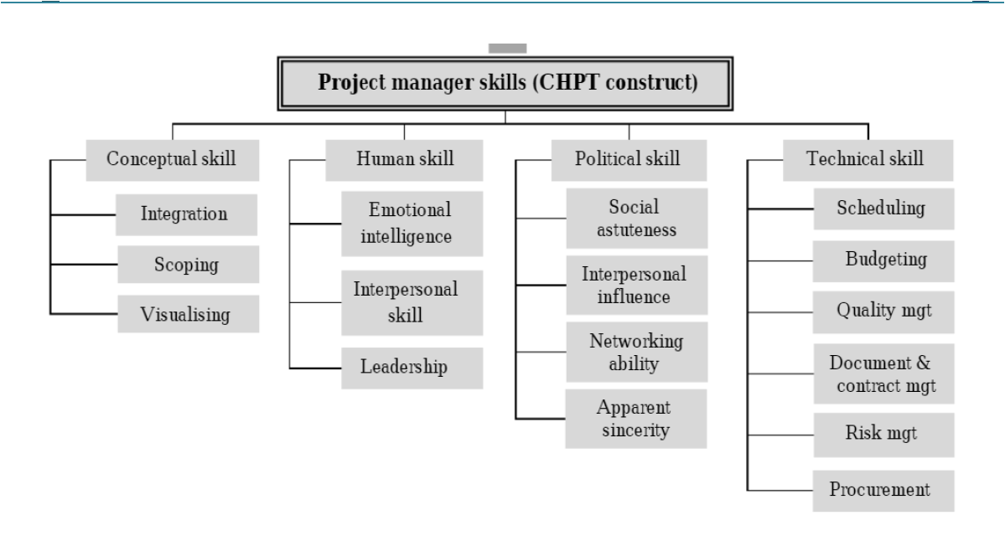

Figure 1: Theoretical framework of the essential project manager skills (CHPT construct)

The emergence of the CHPT construct stems from an analysis of 16 studies presented in the preceding section. This study puts forth four fundamental skill sets for construction project managers, denoted as CHPT construct, with C representing conceptual skill, H for human skill, P for political skill, and T for technical skill. The formulation of the CHPT construct is primarily grounded in Katz's (1974) seminal work, which established the basis for the universal acceptance of the three-skill approach. It is imperative to uphold this common foundation for prospective research endeavors in this domain. Moreover, an additional skill, political skill, is advocated for inclusion as essential for construction project managers due to the increasing significance of political considerations in construction project management.

Initially, El-Sabaa (2001) delineated three skill categories encompassing human, conceptual, organizational, and technical skills. Further examination of El-Sabaa's work reveals that political sensitivity, a component within the human skill category, can be linked to the political skill posited in this study. Additionally, Lei and Skitmore (2004) highlighted networking skills as a crucial attribute for project managers, closely aligned with the networking ability dimension of political skill, which involves cultivating diverse networks to attain project or organizational goals. Subsequently, political skill encompasses aspects such as self-assurance, group process management, utilization of socialized power, and unilateral power utilization as proposed by Gillard and Price (2005). Individuals with heightened political skills exhibit an optimal level of self-confidence, positively perceived by others (Ferris et al., 2000). Effective team performance is shown to be influenced by political skill, as demonstrated in a study by Ahearn et al. (2004). The utilization of socialized power pertains to forming networks and alliances, resonating with the networking ability inherent in political skill (Ferris et al., 2005).

Fourth, PMI (2008) posited that the essential skills for project managers include influencing, political awareness, and cultural awareness. These skills are closely intertwined with the concept of political skill, as previously discussed. Fifth, Dainty et al. (2003) proposed that mutuality, approachability, honesty, integrity, and external relations are also facets of political skill. Individuals with high political skills possess the ability to navigate various social scenarios in the workplace with authenticity, thereby exuding approachability and displaying commendable characteristics. Block (1983) further elaborates on the importance of project managers engaging with external stakeholders who wield influence over the project's success, aligning with Dainty et al.'s (2003) notion of external relations.

Sixth, Cheng et al. (2005) introduced the concepts of impact, influence, directiveness, teamwork, and cooperation as elements related to motivating others to perform effectively, which mirrors the essence of political skill. Seventh, Chen et al. (2008) highlighted the significance of relationship-building as a crucial competency in construction project management. This competency resonates with the social astuteness aspect of political skill, where individuals with high political skills are perceived as resourceful and adept in interpersonal interactions (Ferris et al., 2005). Lastly, political skill fosters high adaptability due to individuals' social astuteness, as noted by Ferris et al. (2007), aligning with the personal adaptability skill outlined by Farooqui et al. (2008).

### 3.1.2 The development of the CHPT construct

This section delves into the CHPT construct comprehensively, examining the elements that constitute each skill construct. Previous research often lacked a detailed explanation of the components necessary to demonstrate essential skills in practical settings. This study seeks to address this gap by discussing how each component can be applied within the construction industry.

#### 1. Chpt: Conceptual Skill Construct

Conceptual skill refers to "the capacity of a project manager to envision the project in its entirety". This skill acknowledges the interdependence of various project functions, where changes in one aspect can impact others (El-Sabaa, 2001). Conceptual skills are crucial for handling abstract scenarios, taking a holistic view of the project, understanding inter-departmental relationships, and envisioning the project within its broader context. The conceptual skills of decision-makers and implementers are vital for project success. For example, when a significant change is made to a project aspect, the project manager must consider its effects on progress, control, budget, schedule, and stakeholders involved (Katz, 1974).

Goodwin (1993) emphasized the importance of a high level of conceptual skills for project managers given the diverse nature of project systems. He further explained that a lack of conceptual skill in project managers has led to issues resulting in project failure. This study posits that the conceptual skill construct comprises three components: visioning, scoping, and integration. These components play a crucial role in planning, organizing, legal comprehension, problem-solving, and decision-making within projects.

* **Visioning**

Visioning involves the ability to perceive the project as a whole and understand its relationship to the organization, industry, community, and external environments (El-Sabaa, 2001). This skill is essential for project managers to maintain a clear focus on outcomes and progress. By envisioning, project managers can grasp what needs to be accomplished at each project stage, adapting plans based on new insights and knowledge.

* Scoping

Scoping refers to the skill of defining and managing what should and should not be included in the project. The project manager's scoping skills are critical in ensuring that all necessary work is accounted for to complete the project (PMI, 2008). This skill is also crucial for establishing a contractual agreement where the project scope must be clearly outlined to prevent future disputes and legal issues that could negatively impact involved parties.

* Integration

The process of integration is crucial for project managers as it involves the comprehensive identification, definition, combination, unification, and coordination of all project aspects. An illustration of this skill in action during the planning phase includes integrating project tasks, sequencing and timing of activities, as well as the allocation of necessary resources to execute and finalize the project. Similarly, in the design phase, project managers must integrate various design elements such as structure, architecture, mechanical, electrical, and interior components to ensure their seamless functionality. Moreover, integration plays a key role during the construction phase by aiding in decision-making regarding the allocation of resources and effort, managing diverse project challenges, and navigating trade-offs among different objectives and alternatives (PMI, 2008).

#### 2. CHPT: Human Skill Construct

Human skill pertains to the capacity to collaborate with and through individuals (Goodwin, 1993; Katz, 1974). In the realm of construction projects, numerous stakeholders with vested interests are involved in or impacted by the project. Given that each stakeholder harbors distinct expectations, project managers must leverage their human skills in stakeholder management. Additionally, as individuals are the ones executing tasks at each stage of the construction project life cycle, a profound comprehension of human skills is essential for effectively managing these personnel. The efficacy of a project manager heavily relies on their ability to foster collaborative endeavors within the project team and other stakeholders involved. This study identifies three fundamental components of the human skill construct, namely emotional intelligence, interpersonal skill, and leadership. Emotional intelligence enables project managers to be self-aware, regulate their emotions, and comprehend the emotions of others. By grasping these emotional dynamics, project managers can utilize their interpersonal skills to cultivate relationships. Subsequently, by establishing rapport with others, project managers can apply their leadership skills to guide individuals toward goal achievement.

Emotional intelligence refers to the ability to identify one's own emotions and those of others, to self-motivate, and to effectively manage emotions within oneself and in interpersonal relationships, as defined by Goleman (1998: p.375). Goleman (2001) delineated the four facets of emotional intelligence as self-awareness, self-management, social awareness, and relationship management. Self-awareness involves recognizing one's current emotions and utilizing them in decision-making processes. Individuals with high self-awareness acknowledge their strengths and weaknesses, are receptive to feedback, and are open to learning from past experiences. Self-management entails the capacity to regulate negative emotions like anxiety and anger, as well as to control impulsive emotional reactions, enabling individuals to focus on positive feelings linked to goal achievement while curbing negative emotions. Individuals with strong self-management skills often exhibit enhanced motivation. Social awareness enables individuals to perceive the emotions of others, including interpreting nonverbal cues to grasp emotional undercurrents. This skill is particularly crucial in roles that involve significant interpersonal interactions, such as job performance. Moreover, relationship management involves the ability to align with or influence the emotions of others.

Carmeli (2003) posited that senior managers with high emotional intelligence perform better in their roles compared to their peers. highlighted that emotional intelligence fosters delegation, open communication, and proactive behaviors among construction project managers and engineers, leading to favorable project outcomes.

Interpersonal skill refers to the ease and effectiveness of communication between project managers and various stakeholders, including staff, colleagues, superiors, and clients (Peled, 2000). identified four common interpersonal challenges in project environments that project managers must navigate. The first challenge involves motivating project stakeholders, a task made complex by the limited formal authority and influence typically held by project managers, hindering efforts to inspire others toward project goals. Conflicts represent the second challenge, being a norm in organizational settings, though project managers must adeptly manage conflicting stakeholder expectations, which are heightened in project settings. Ineffective communication emerges as the third challenge, with common issues including information flow gaps within project teams and stakeholders, misinterpretations, information overload, data unavailability, and delayed information sharing. The final challenge is the lack of teamwork and cooperation, often stemming from individualistic tendencies among stakeholders that impede collaboration and communication. Team members may lack the willingness or ability to cooperate, driven by personal career aspirations and competitive mindsets, sometimes leading to envy and jealousy towards successful colleagues.

Project managers must possess a comprehension and application of motivation, conflict resolution, effective communication, and team development to address these interpersonal challenges. Initially, an insight into human behavior is crucial for project managers to inspire individuals. Numerous motivational theories have been formulated for this purpose. Within a project setting, Rahim (1992) recommended that motivating others involves explaining their role in the project, assigning suitable positions, illustrating the impact of their contributions, maintaining a positive demeanor, setting realistic challenges, establishing clear performance standards, and providing honest evaluations. Additionally, project managers must utilize various conflict management styles to address disputes effectively. identified five conflict resolution styles: avoidance, domination, accommodation, compromise, and collaboration. Project managers need to select the most suitable style to ensure project objectives are achieved without hindrance.

Moreover, effective communication skills are imperative for project managers to tackle communication issues. proposed that effective communication involves active listening, proficient verbal, graphical, and written skills, adept delivery of news, strong presentation abilities, stakeholder liaison, and robust networking skills. Furthermore, fostering teamwork and collaboration is crucial for project managers by demonstrating a genuine willingness to cooperate and providing adept team leadership through diverse approaches to maximize team performance. Team building is an ongoing process, necessitating continuous monitoring of team dynamics and performance to address any issues that may arise (Rahim,1992).

Regarding leadership, Drucker (1996) defined leadership as the ability to garner followers. Leadership is viewed as the process of guiding a group towards common objectives, hence leaders are instrumental in driving progress. In construction projects, the project manager assumes the role of project leader. Effective leadership is crucial for project managers to unify team members and motivate them toward achieving project goals.

Numerous studies have explored leadership concepts and theories over time. Research indicates that transformational leadership is effective as it elicits heightened effort and performance levels from employees, surpassing those achieved through transactional approaches based on reward and punishment systems. A study demonstrated that project managers utilizing transformational leadership witnessed project success, emphasizing the importance of adopting a relationship-oriented approach towards the project team to ensure project success (Prabhakar, 2005).

#### 3. CHPT: Political Skill Construct

Ahearn et al. (2004: p.311) conceptualized political skill as the adeptness to comprehend and effectively influence others in the workplace to advance personal and/or organizational objectives. Distinguishing between political and human skills is imperative. Human skill pertains to the fluidity and efficacy of communication between project managers and stakeholders. However, the success of projects may not solely rely on interpersonal likability; rather, it hinges on political astuteness, denoting the capacity to navigate interpersonal relationships strategically to ensure project success (Peled, 2000). underscored that political skill is tailored to organizational settings, and aimed at maneuvering interpersonal dynamics to achieve organizational objectives. Unlike conventional human skills, political skill surpasses mere interaction proficiency, focusing on leveraging relationships to accomplish individual and organizational goals (Ferris et al., 2005).

Though some perceive politics as unsavory and detrimental to organizations, research suggests that adept employment of political skills is pivotal for managerial advancement. Organizations inherently foster political climates characterized by competing interests, resource constraints, coalition building, and power dynamics, necessitating adept political maneuvering to drive initiatives forward.

Pinto (2000) contended that political processes permeate project management due to its intrinsic nature. Project managers must adeptly influence stakeholders to secure necessary resources for project success. Recognizing this, successful project managers prioritize cultivating strong political networks as a means to ensure project success. Block (1983: p.21) defined project politics as “the actions and interactions between project team members and people outside the team that have an impact on the project's success,” emphasizing the pivotal role of project managers in navigating external interactions crucial to project outcomes.

Ferris et al. (2005, 2007) delineated four key dimensions of the political skill construct:

1. **Social Astuteness:** Individuals with high political skills exhibit keen observation of social dynamics, adeptly interpreting behaviors in diverse social contexts. They demonstrate sensitivity and ingenuity in managing interpersonal interactions to achieve desired outcomes.
2. **Interpersonal Influence:** High political skill entails a persuasive personal style that exerts influence over others, allowing for adaptability in behavior to elicit desired responses. Unlike traditional interpersonal skills, interpersonal influence focuses on manipulating relationships to ensure project or organizational success.
3. **Networking Ability:** imperative for project managers to cultivate cooperation and ensure the triumph of projects. Proactive behavior encompasses the initiation of communication and the delivery of value through diverse avenues. Demonstrating curiosity involves displaying genuine interest, actively engaging in listening, and showing appreciation. Strategic planning plays a pivotal role in establishing objectives, identifying pertinent connections, and prioritizing duties. The quality of adaptability enables the adjustment of communication styles and mediums. Collaboration encompasses the sharing of resources and soliciting feedback from connections. Authenticity fosters trust and rapport by embodying genuineness and dependability in engagements.
4. **Apparent Sincerity:** Perceived integrity, authenticity, and genuineness characterize individuals with high political skills, fostering trust and confidence among peers. Genuine intentions devoid of ulterior motives enhance the success of influence attempts, as they are perceived as authentic and trustworthy.

#### 4. CHPT: Technical Skill Construct

Technical expertise involves specialized knowledge and techniques required for effective task performance. This includes a deep understanding of the subject matter, strong analytical capabilities, and mastery of tools and methods specific to the field (Katz, 1974). Based on existing research, this paper highlights six crucial technical skills essential for construction project managers:

1. **Scheduling:** considered crucial in the realm of construction project management as it encompasses the process of determining activity timelines, dependencies, resource allocation, and risk assessment to guarantee the timely completion of projects. A well-designed construction schedule delineates the project's timeline and milestones, effectively coordinating tasks such as site preparation, foundational work, structural construction, mechanical and electrical installations, and finishing activities. This approach optimizes resource usage, coordinates project timelines, reduces delays, and ensures the successful conclusion of the project within the specified timeframe (PMI, 2008).
2. **Budgeting and Cost Management:** Crucial for project fiscal viability, budgeting involves resource estimation, cost allocation, and proactive budget control to prevent cost overruns and ensure project profitability. An effective construction schedule aids in better control over project timelines and costs. It helps track progress, identify delays, and implement corrective actions promptly. By adhering to the schedule, construction projects can be completed on time and within budget (PMI, 2008).
3. **Quality Management:** Ensuring adherence to quality standards is paramount in construction projects, necessitating continuous monitoring, evaluation, and corrective action to meet or exceed predefined quality benchmarks (PMI, 2008). Quality management in construction encompasses processes and procedures to ensure a project meets its requirements and standards, including safety, cost, schedule, and performance. The goal is to prevent defects, reduce waste, and enhance efficiency. Effective quality management can reduce costs, improve safety, and lead to better project outcomes and greater customer satisfaction.
4. **Document and Contract Administration:** Proficiency in contract management involves understanding contractual obligations, administering contract terms, and meticulous documentation of project activities to ensure compliance and mitigate disputes. Effective document and contract administration also ensures that all project plans, timelines, and changes are accurately recorded. This documentation provides a basis for accountability, enabling project teams to refer for audits, compliance checks, and legal purposes. (Fisk, 1997).
5. **Risk Management:** Effective risk management is a crucial skill for a construction project manager. By identifying and assessing potential risks, they can develop strategies to mitigate their impact on the project. Proactive risk management ensures that the project can progress smoothly without major disruptions, and analyzing risks and creating contingency plans prepares the project for unexpected events and mitigates risks throughout the project lifecycle, ensuring project objectives are achieved within stipulated constraints (Standards Australia, 2009).
6. **Procurement Management:** Effective Procurement management in construction involves sourcing the products, services, and equipment needed to complete a project. This process includes strategic planning, vendor selection, contract administration, and logistics management. The project manager and procurement team collaborate to ensure materials and services meet quality standards and are delivered on time and within budget. Effective procurement requires negotiating with contractors and suppliers to secure the best price and timeframe, overseeing logistics to ensure timely delivery, and managing multiple vendors simultaneously. Proper procurement management is essential for ensuring project success and meeting all project requirements. (PMI, 2008).

## 3.2 LEVERAGING GENAI IN PROJECT MANAGEMENT: STRATEGIES, OVERSIGHT, AND BUSINESS IMPACT IN CONSTRUCTION

### 3.2.1 Overview

In the context of construction project management in Australia, my research investigates the multifaceted potential of Generative AI (GenAI) to automate routine tasks, assist in complex decision-making processes, and augment overall project management capabilities. The critical aspect of this research is recognizing the necessity of human oversight, especially as task complexity increases, to ensure the effective integration of these technologies.

### 3.2.2 Leveraging GenAI for Project Management Tasks

1. **Automation of Routine Tasks** GenAI has demonstrated significant potential in automating routine project management tasks, such as scheduling, resource allocation, and reporting. AI-driven tools can streamline these processes, reducing the time and effort required and minimizing human error. For example, in a large-scale construction project, AI can automatically update schedules in real time based on actual progress data from site sensors and worker input, predict potential delays, and suggest corrective actions. This automation allows project managers to focus on more strategic aspects of the project.
2. **Assistance in Decision-Making** In more complex scenarios, GenAI assists project managers by providing data-driven insights and predictive analytics. This includes risk assessment, cost estimation, and scenario planning. For instance, in a high-rise building project, AI models can analyze historical project data to forecast potential risks such as supply chain disruptions or adverse weather conditions and their impacts. This allows project managers to proactively mitigate these risks by adjusting schedules, securing alternative suppliers, or implementing weather-proofing measures.
3. **Augmentation of Capabilities** GenAI augments the capabilities of project managers by offering enhanced data analysis and visualization tools. These tools help in making more informed decisions, optimizing resource utilization, and improving overall project outcomes. In a road construction project, advanced AI algorithms can analyze vast amounts of data from traffic patterns, material supply chains, and labor availability to identify patterns and trends. This information can then be used to optimize resource allocation, reduce costs, and minimize project delays.

### 3.2.3 Ensuring Adequate Oversight of GenAI Outputs

1. **Human Oversight and Intervention** Despite the advantages of GenAI, human oversight remains crucial, especially as the complexity of tasks increases. Project managers must regularly review AI-generated outputs to ensure they align with project goals and comply with industry standards. For example, in a coastal infrastructure project, project managers need to cross-verify AI-generated risk assessments and mitigation strategies with on-ground realities, such as local environmental regulations and community feedback, to make informed final decisions.
2. **Training and Development** To ensure effective oversight, it is essential to equip project managers with the necessary skills to understand and interpret AI outputs. Organizations conduct regular training sessions and workshops to familiarize their teams with the latest AI tools and techniques. For instance, a construction company might implement a training program focused on using AI for predictive maintenance of equipment, helping managers anticipate machinery breakdowns and schedule timely repairs, thus minimizing downtime.
3. **Collaborative Decision-Making** A collaborative approach is encouraged where AI-generated insights are discussed in team meetings, allowing for diverse perspectives and expert opinions to shape final decisions. This collective oversight helps in identifying any potential biases or errors in AI outputs and ensures that decisions are well-rounded and robust. For example, during the construction of a new hospital, AI-generated schedules, cost estimates are reviewed and discussed in team meetings, ensuring alignment with project goals and stakeholder expectations.

### 3.2.4 Reviewing Processes and Integrating GenAI Tools

1. **Continuous Process Improvement** As part of ongoing efforts to integrate GenAI into the project management framework, regular reviews and updates of processes, practices, and techniques are essential. This includes assessing the performance of AI tools, identifying areas for improvement, and incorporating feedback from project managers and other stakeholders. For instance, a construction firm may continuously evaluate the effectiveness of AI-driven project management tools and make adjustments based on real-world performance and user feedback.
2. **Pilot Projects and Case Studies** Initiating pilot projects to test new AI tools and methodologies before full-scale implementation is crucial. These pilot projects help in understanding the practical challenges and benefits of AI integration in a controlled environment. For example, a pilot project in a residential development might use AI to optimize construction schedules and resource allocation, providing valuable insights that inform broader AI strategy across the organization.
3. **Stakeholder Engagement** Engaging with stakeholders, including clients, contractors, and team members, is essential for the successful integration of AI tools. Involving them in discussions about the benefits and limitations of AI, addressing concerns, and setting realistic expectations about what AI can achieve in project management is critical. For instance, during the construction of a sports facility, regular stakeholder meetings can help ensure that AI-driven decisions align with the needs and expectations of all parties involved.
4. **Ethical Considerations** Ensuring that AI use adheres to ethical guidelines and industry standards is paramount. This includes maintaining transparency about how AI tools are used, protecting data privacy, and ensuring that AI-driven decisions do not negatively impact project stakeholders. For example, in a sustainable construction project, ethical considerations might involve using AI to minimize environmental impact and ensure compliance with green building standards.

### **3.2.5 Enhancing Ways of Working, Power Skills, and Business Acumen**

Artificial intelligence (AI) has significantly influenced project work and the role of project managers, including those in the construction industry. According to the 2023 PMI Annual Global Survey on Project Management, 21% of respondents report using AI frequently in project management, and 82% of senior leaders believe AI will impact project execution in their organizations over the next five years. Additionally, 91% of respondents from an unpublished PMI Customer Experience (CX) survey predict AI will have at least a moderate impact on the profession, with 58% foreseeing a “major” or “transformative” effect.

The introduction of Generative AI (GenAI), particularly with the public release of OpenAI’s ChatGPT in November 2022, has accelerated AI's influence on construction project management. To increase productivity, efficiency, and project success, project managers must explore and leverage AI opportunities. Fluency in AI basics is now essential. However, PMI's CX research highlights an urgent need for upskilling, as only about 20% of project managers have substantial experience with AI tools, and 49% have little to no experience or understanding of AI in the context of project management. Project managers who lead the adoption of AI within their organizations will be best positioned for career success.

The PMI Talent Triangle® offers a robust framework for project managers to understand and develop the necessary skills and competencies to leverage GenAI technology. This framework encompasses three key aspects: Ways of Working, Power Skills, and Business Acumen (Figure 2).

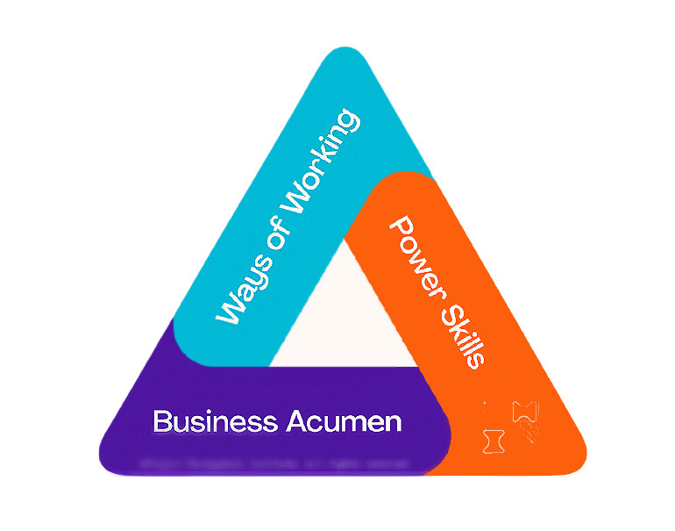

Figure 2: The PMI Talent Triangle® and GenAI in Construction Project Management

1. **Ways of Working:** In construction project management, GenAI can automate routine tasks such as scheduling, risk management, and resource allocation. For example, AI-driven software like Doxel uses computer vision and deep learning to monitor construction sites in real time, identifying deviations from project plans and enabling proactive management. Project managers need to adopt these technologies to streamline operations and enhance decision-making processes.
2. **Power Skills:** Effective communication, leadership, and adaptability are crucial in managing AI-integrated projects. In Australia, the construction firm Lendlease has implemented AI to improve project delivery. By using AI to predict project outcomes and optimize workflows, project managers can focus on strategic tasks and stakeholder engagement, ensuring smoother project execution and increased client satisfaction.
3. **Business Acumen:** Understanding the financial and strategic implications of AI adoption is vital. Australian construction companies like John Holland Group use AI for predictive analytics, helping project managers anticipate cost overruns and delays. This foresight enables better financial planning and risk mitigation, ultimately leading to more successful project outcomes.

* Case Study: Sydney Metro Project

The Sydney Metro project exemplifies AI's potential in construction project management. By incorporating AI technologies such as machine learning and data analytics, the project team optimized tunneling processes and improved safety measures. AI-powered systems provide real time data on ground conditions, allowing for immediate adjustments and reducing project delays. This approach not only enhanced efficiency but also demonstrated the transformative impact of AI in large-scale construction projects.

* 1. Way of Thinking

Whether it is predictive, agile, design thinking, or emerging practices yet to be developed, it is evident that there exists a variety of approaches through which work is carried out in the contemporary setting. This underscores the importance for project professionals to adeptly familiarize themselves with multiple methodologies to deploy the appropriate one at the opportune moment, thereby yielding successful outcomes. The component of the PMI Talent Triangle® known as Ways of Working is centered on the adoption of optimal strategies, methodologies, techniques, and tools to effectively steer projects to success. Given the extensive accessibility and potential of Generative AI tools at both individual and organizational tiers, it is crucial to leverage the enhanced results that GenAI can facilitate project managers in achieving. Conceptualize "ways of working" as sequences of events and activities aimed at delivering an outcome, with generative AI capable of automating, aiding, or enhancing project management proficiencies and competencies. For instance:

1. **Project planning:** Employ GenAI to streamline the extraction and analysis of historical data for aiding overall project planning and enhancement, as well as for generating comprehensive project documentation encompassing all Knowledge Areas of the PMBOK® Guide.
2. **Time and cost management:** Utilize GenAI to bolster time and cost estimation and refinement, back cost-benefit analysis, conduct earned value analysis, and compute and identify mitigation measures to address cost overruns, delays, and similar issues.
3. **Risk management:** GenAI can provide support and guidance for risk recognition, analysis, and general suggestions for risk mitigation and eradication. It can assist in outlining risk planning and reports, and bolster communication.
4. **Writing and reading support:** GenAI is extensively employed to enhance writing, including documents and emails, to support general and specific communication tasks. It can also be utilized for code generation, summarizing meeting notes and insights from previous projects, and extracting data from unstructured sources. Understanding the essential relationship between data and AI is crucial for project managers, who should also be familiar with their organization's data strategy and protocols. By grasping how data impacts these tools, project managers will be better equipped to comprehend and evaluate AI outcomes. Developing data literacy will enable project managers to customize tools and models for specific projects, such as predicting project outcomes, risks, and resources, to provide accurate forecasts and analyses for decision-making. This expertise will also help project managers recognize and mitigate the potential risks associated with the deployment of GenAI in the business.

* 2. Power Skills

These interpersonal skills encompass collaborative leadership, communication, problem-solving, and strategic thinking. Ensuring that teams possess these skills enables them to maintain influence with various stakeholders — a crucial element in driving change. The 2034 edition of PMI’s Pulse of the Profession® identified four vital power skills necessary for organizations to undergo transformation and achieve sustainable outcomes: strategic thinking, problem-solving, collaborative leadership, and communication. All of these represent human attributes that can be somewhat enhanced by artificial intelligence. For instance, project managers can contribute more strategically to their projects and organizations by leveraging AI tools in different facets of their business, industry, and market to resolve issues more efficiently and expeditiously.

1. **Incorporate strategic thinking:** GenAI comprehends strategic models and frameworks adeptly. Even if one lacks a profound understanding of the organizational strategy beyond the overarching document, delineating the probable components of the strategy for a similar organization will reveal numerous fundamental, yet significant, interconnections that might have been overlooked.
2. **Enhance collaboration:** Initiating GenAI's involvement at the outset of collaboration enables the team to commence from a different standpoint, thereby bypassing the rudimentary brainstorming that typically dominates initial meetings.
3. **Expedite problem-solving:** Effective problem-solving in project management necessitates a variety of viewpoints. GenAI can aid in resolving specific elements of the issue, conducting research, and proposing hypotheses. It is important to note, however, that it lacks a holistic perspective to integrate all components due to its general knowledge of the specific business context within your company.
4. **Refine communication:** Employ GenAI to streamline communication across various levels, including bolstering stakeholder management, recommending supporting data, automating simpler communication processes, and assessing content to effectively convey the appropriate narrative and viewpoint in more intricate and delicate messages.

Power skills are poised to increasingly serve as a competitive advantage, determining the success or failure of every project as AI advancements free up more time for human interaction. PMI's research, alongside numerous comprehensive studies conducted over the past two decades, consistently highlights human-related factors as among the primary causes of project failures.

It is crucial to remember that algorithms cannot establish personal connections, challenge authority, uphold ethical standards, or be answerable for their choices. Project managers possess the ability to perform all these tasks and more, including engaging with individuals, demonstrating empathy, adapting, devising unconventional solutions, making decisions amidst uncertainty, negotiating, managing stakeholders, leading, and motivating. Project managers possess skills that machines will never acquire, irrespective of how intelligent they may become.

* 3. Business Accuman:

Professionals possessing business acumen comprehend the macro and micro influences within their organization and industry. They are equipped with domain-specific knowledge to facilitate informed decision-making. Individuals at various hierarchical levels must develop the capability to foster effective decision-making skills. It is crucial for them to grasp how their projects align with the overarching organizational strategy and global trends. Consider a scenario where one seeks a comprehensive understanding of corporate-level risks associated with a project or program. Utilizing AI can provide valuable insights for conducting a thorough business risk analysis and impact evaluation. This proactive approach enables organizations to devise a recovery plan and anticipate mitigation strategies in advance of potential disruptive events.

The utilization of GenAI's multimodal data capability enables the support of analysis from diverse sources like text and images. This facilitates the provision of more relevant information aligned with the specific problem and business sector. Moreover, it proves beneficial in predicting outcomes under various business conditions and scenarios. The customization of prompts and questions using GenAI tools empowers project managers to access data-driven insights swiftly. This expedites the identification and implementation of business innovation initiatives.

GenAI can be harnessed to assess and comprehend the business implications of projects. By leveraging GenAI, one can gain insights into the impact and contribution of projects on the overall business. Furthermore, employing GenAI aids in comprehending the intricate web of interdependencies within a project and its broader organizational or environmental context.

The integration of AI tools contributes to the enhancement of business acumen in two key ways. Firstly, by automating mundane tasks, project managers can allocate more time to understanding intraorganizational influences and relationships. Secondly, GenAI empowers project managers to discern the strategic implications of their work. This enables them to engage in strategic discussions with senior stakeholders and make well-informed decisions regarding their projects. The incorporation of these tools may necessitate a shift in the types of business acumen that project managers are required to master.

For instance, generative AI simplifies the process for project managers to view situations from the vantage point of industry experts through prompts. Consequently, the retention of general industry knowledge may become less critical. However, a detailed understanding of the organization's competitive advantages and the potential leverage from existing ecosystem data or new project-generated data remains imperative.

Functional operations are increasingly becoming more automated and transparent. These ubiquitous software-as-a-service (SaaS) facilitated processes are typically well-defined within general datasets. It is the business acumen distinguishing one's organization that plays a crucial role in this context. The distinguishing factors lie in what renders the organization unique, more efficient, and ultimately more effective. This depth of comprehension not only establishes a strong linkage with the project strategy but also ensures the alignment of all project-to-organization interfaces for the successful attainment of objectives.

GenAI interfaces empower project managers and team members to efficiently explore and retrieve pertinent information, thereby obtaining customized outcomes without necessitating extensive programming proficiency. This advancement elevates data-driven decision-making by granting real time access to enterprise and historical project data, thereby facilitating the extraction of pertinent insights and intelligence precisely when needed.

# 4. METHODS & FINDINGS

## 4.1 Data Collection and Analysis

The data collection process comprised two primary stages. Initially, relevant sources were meticulously identified and selected for the research. Subsequently, an exhaustive elimination process was conducted to exclude sources tangentially related to project management expertise, ensuring a focused analysis of competencies pertinent to the construction industry.

## 4.2 Findings

The examination of construction project manager skills unveiled significant impacts, not only on individual project success but also on broader economic indicators such as national GDP. For instance, a 2017 study by McKinsey suggested that enhancing project management practices in construction could potentially increase global GDP by 2% annually, highlighting the pivotal role of proficient project managers in driving economic development.

The COVID-19 pandemic has significantly reshaped the requisite skills for effective project management in the construction sector. A 2021 survey by the Associated General Contractors of America (AGC) revealed that 78% of construction companies experienced project delays due to disruptions in the supply chain and workforce shortages. Consequently, project managers now necessitate heightened adaptability and crisis management abilities. The pandemic has also accelerated the adoption of digital project management tools and technologies, underscoring the importance of digital literacy as a fundamental competency.

Generative AI is progressively revolutionizing project management in the construction industry. AI-driven tools now possess the capability to optimize project schedules, predict potential delays, and enhance resource allocation. A 2023 report by Deloitte disclosed that 45% of construction firms have integrated AI technologies into their project management processes, emphasizing the growing significance of technological expertise and data analysis skills for contemporary project managers. Furthermore, the Project Management Institute (PMI) has documented several case studies illustrating how AI has improved construction project manager efficiency, particularly in areas such as risk management and decision-making.

Recent surveys, including the KPMG Australian Infrastructure Investment Survey, provide additional insights into the evolving landscape of construction project management. This survey highlighted job growth within the sector and identified significant talent discrepancies, particularly a shortage of skilled project managers capable of leveraging advanced technologies. The findings indicate a critical need for ongoing training and development to bridge this talent gap and support the sector's growth.

In the Australian context, there has been a marked increase in the adoption of AI and digital tools in construction project management. The current scenario shows that Australian firms are increasingly relying on these technologies to enhance efficiency, improve project outcomes, and maintain competitiveness in a rapidly evolving market.

Upon literature review, several indispensable skills emerged as critical for construction project managers:

1. **Leadership and Communication:** Effective leadership and clear communication are paramount. A 2020 study by the Project Management Institute (PMI) indicated that 90% of successful projects were overseen by managers with robust communication skills.
2. **Technical Proficiency:** Understanding construction-specific technologies and methodologies is vital. For example, Building Information Modeling (BIM) has become a standard tool, with a 2019 survey by Dodge Data & Analytics revealing that 70% of construction firms utilize BIM in their projects.
3. **Risk Management:** The ability to anticipate and mitigate risks has become more crucial than ever. The aforementioned AGC survey highlighted that 60% of companies intensified their focus on risk management post-COVID-19.
4. **Adaptability and Problem-Solving:** The dynamic nature of the construction sector necessitates managers who can swiftly adapt and resolve issues effectively. A 2021 study by KPMG demonstrated that adaptive project management practices resulted in a 30% enhancement in project outcomes.
5. **Financial Acumen:** Grasping financial management and cost control is essential for project success. According to the Construction Financial Management Association (CFMA), adept cost control practices can decrease project expenses by up to 15%.

These findings underscore the evolving skill set required for construction project managers, highlighting the importance of both traditional competencies and emerging technological proficiencies in driving project and economic success.

# 4. RESULTS & DISCUSSION:

## 4.1 Summary Table (15 Articles)

|  |  |  |  |  |  |  |
| --- | --- | --- | --- | --- | --- | --- |
| **SR.NO.** | **Full Citation** | **Research Aim** | **Research Questions** | **Main Findings** | **Limitations** | **Usefulness/Relevance** |
| 1 | Rezende, L. B. D., Blackwell, P. (2019). Iberoamerican Journal of Project Management. | Review literature on project management competency to develop assessment instrument. | Identify project managers' competency profile based on 81 competencies.  Develop a project management competency assessment instrument for practitioners and academics. | Project managers' competency profile: 81 competencies across 11 dimensions.  48 competencies correlated with project success, focusing on leadership and teamwork. | Fragmented knowledge on project management competencies.  Lack of a complete competency framework beyond technical skills. | Project management competency framework relevance in project manager development.  Importance of competencies like communication, teamwork, and political awareness.  Teamwork skills, collaboration, support, delegation, and trustworthiness.  Clear communication, presentation, and engaging skills for project effectiveness. |
| 2 | Odejide, Edunjobi. (2024). AI in Project Management: Theoretical Models. | Explore AI's role in personalized marketing for consumer engagement and loyalty. | How AI enhances personalized marketing for consumer engagement and loyalty.  AI's role in project management for decision-making and risk mitigation. | AI enhances project management decision-making and risk mitigation.  Responsible AI implementation is crucial for project success and ethical practices.  AI optimizes resource allocation, scheduling, and cost savings in projects. | Data bias can lead to flawed AI recommendations in project management.  AI lacks human capacity for critical thinking and emotional intelligence.  Human oversight is needed as AI cannot replace project managers. | The research paper explores AI's transformative potential in personalized marketing.  It discusses responsible AI implementation for project success. |
| 3 | Achara Khamaksorn. Project Management Knowledge and Skills for the Construction Industry. | To develop project management knowledge and skills in the construction industry.  Analyze ways for implementing construction project management effectively. | How to develop project management knowledge and skills in the construction industry?  What are the essential competencies for effective project management in construction? | Scheduling and planning management are significant knowledge areas.  Delegation, leadership, decision making, and problem-solving are essential skills.  Project manager's role is crucial for construction project success. | Not mentioned | The research paper focuses on project management knowledge and skills.  It discusses competencies essential for successful construction projects. |
| 4 | Obradović, Montenegro, & Bjelica. Project Management Journal. | Identify critical competencies for project managers in the digital era.  Assess the importance and self-assessment of project manager competencies.  Shift focus from technical to soft skills due to digital age. | Identify critical competencies for project managers in the digital era.  Assess the importance and self-assessment of project manager competencies. | Conceptual and people skills are critical for project managers.  Technical skills are significant but less important in the digital era.  Respondents possess political, conceptual, and human competencies | Limited focus on technical skills due to digital era shift.  Research was conducted on 52 project managers from renowned companies. | The research focuses on project manager competencies in the digital era.  The study highlights the shift from technical to soft skills. |
| 5 | Project Managers’ Competencies- Survey of perspective from project manager in southeast Queensland | the most important skills that an effective project manager should possess are the ability to communicate, followed by ability to meet project objectives and ability to make decisions in general |  | In contrast. ability to use computer/project management software and ability to manage legal issues are the least important skills.  The biggest gap between skills needed and skills possessed is in communication | Limitations include complex equations and data interpretation challenges | It was found that the ability to communicate, the ability to meet project objectives and make decisions are the most important skills needed. |
| 6 | F. Edum-Fotwe, R. McCaer. International Journal of Project Management 18 (2000) 111-124. | Explore project managers' competency development in the construction industry.  Identify essential knowledge and skills for project management certification. | Focus on project managers' competency development in changing construction industry.  Identify essential knowledge and skills for project management certification. | Project managers need diverse skills beyond engineering for adaptation.  Surveyed project managers value leadership and communication skills for competency. | Academic knowledge insufficiency for modern construction project managers.  Experience adaptation to changing industry conditions is crucial for competency. | The research focuses on project management competency in the construction industry.  The relevance is about developing skills for project managers. |
| 7 | Jaser Mahasneh, Walid Thabet. Rethinking Construction Curriculum: A Descriptive Cause Analysis. | Define soft skills gap among construction graduates in entry-level positions.  Identify major causes contributing to the soft skills gap. | What causes the soft skills gap among construction graduates?  How can the soft skills gap in construction education be addressed?  What are the major reasons contributing to the soft skills gap?  How can the construction curriculum be improved to bridge the gap? | Soft skills gap in construction graduates due to unclear definitions.  Construction curriculum lacks alignment with industry soft skills requirements.  The existing education system fails to bridge the soft skills gap.  Five major causes contribute to the soft skills gap. | Lack of standardized soft skills classification in construction industry.  Challenges in quantifying soft skills cultivation for effective remedies. | The research paper addresses the soft skills gap in construction graduates. |
| 8 | Title: Key Factors Employers Look for In Hiring Construction Managers | Discuss benefits of project management skills for construction managers.  Identify skills expected by employers when hiring construction managers. | What skills do employers seek in construction managers for projects?  How do project management skills impact construction project success?  What research method was used to gather key factors for hiring supervisors? | Soft skills essential for construction managers, impacting project success.  Construction manager's role crucial, requires management skills for project success.  Self-driven skills vital for construction managers, teamwork essential for success. | The research paper focuses on construction manager skills and employer expectations.  The relevance is limited to construction industry management and soft skills. | Constraints include resource and time constraints, task difficulty, and unexpected changes.  Construction managers need to stay calm and focused under stress. |
| 9 | Title: Relationships of construction project manager, engineer, and foreman skills. | Examine relationships among construction manager, engineer, and foreman skills.  Determine the influence of construction manager skills on engineer skills.  Analyze how engineer skills affect foreman skills in construction projects. | Relationships of construction manager, engineer, and foreman skills examined in study.  Influence of construction manager skills on engineer and foreman skills.  Importance of knowledge management, problem-solving, and physical skills highlighted. | Construction manager skills influence engineer skills (regression weight 0.65)  Engineer skills influence foreman skills (regression weight 0.84)  Knowledge management is crucial for construction managers (regression weight 0.64)  Problem-solving is vital for engineers (regression weight 0.59)  Physical skills are essential for foremen (regression weight 0.67) | Relevance: Relationships of construction project members' skills for project performance.  Not relevant to other topics or industries. | Based on international literature, survey collected within Thai construction industry.  Skills may vary based on cultural differences in different environments. |
| 10 | Rezende, L. B. D., Blackwell, P. (2019). Project management competency framework. | Identify project managers' competencies through systematic literature review. | Identify project managers' competency profile based on 81 competencies.  Develop a project management competency assessment instrument for practitioners and academics. | Project managers' competency profile: 81 competencies across 11 dimensions.  48 competencies correlated with project success, focusing on leadership and teamwork. | Difficulty in coding terms for expressing competencies was a limitation.  Further research needed to explore relative importance based on various factors. | Relevant for project managers, academics, and practitioners in project management.    Provides a comprehensive set of competencies for project management professionals. |
| 11 | Sina Moradi, Kalle Kahkonen, Kirsi Aaltonen. (2020). Project Managers' Competencies in Collaborative Construction Projects. | Identify core competencies and differences between traditional and collaborative projects. | Identify core competencies and differences between traditional and collaborative projects. | 10 core competencies for project managers in collaborative construction projects identified.  7 supportive competencies supplementary to core competencies for project managers. | Limited study on competencies in collaborative construction projects. | Evaluates competencies of project managers in collaborative construction projects in Finland.  Identifies core and supportive competencies for project managers in collaborative projects. |
| 12 | Gunduz, Murat and Ahmad Kamal Hayati Yahya. “Analysis of project success factors in construction industry.” Technological and Economic Development of Economy 24 (2015): 67–80-67–80. | The research aim is to identify and assess the critical project success factors in construction projects, by evaluating their impact and contribution to project performance in terms of schedule, cost, and quality. | What are the critical success factors in the construction industry that contribute to successful project completion? | The main findings of the study highlight the critical success factors in construction projects, with an emphasis on the importance of technical capacity, scope definition, control systems, and effective site management for project success. | - Limited generalizability to developed countries - Small sample size in terms of respondents | offering valuable insights for project participants to enhance project success, and recommending specific factors for management attention. The study's outcomes can benefit the construction industry by guiding project planning and management based on the identified critical factors. |
| 13 | Mouchi, Glen et al. “The Skill Sets Required for Managing Complex Construction Projects.” Labor: Human Capital eJournal (2011): n. pag. | The research aim is to explore the perspectives of senior management personnel in construction organizations on the complexity of construction projects and the skill sets required for successful outcomes. | What skill sets are required to achieve successful outcomes on complex construction projects according to senior management personnel in construction organizations? | Construction projects have unique characteristics, senior management perspectives on complexity and required skill sets, specific skill sets necessary for success in complex projects. | Not mentioned | The abstract emphasizes the importance of specific skill sets for managing complex construction projects, based on insights from senior management personnel in construction organizations. |
| 14 | Gharehbaghi, Koorosh and Kerry Mcmanus. “Effective construction management.” Leadership and Management in Engineering 3 (2003): 54-55. | The research aim is to explore the skills, qualities, and abilities required for effective construction management, particularly focusing on the role of the project manager. | What are the key responsibilities and skills required for an effective construction manager? | An effective construction manager must have many different skills, qualities, and abilities to be able to respond to most of the demanding situations within the construction projects. | Not mentioned | The relevance in Koorosh Gharehbaghi, K. Mcmanus (2003) lies in discussing the role and responsibilities of a project manager in construction management, as well as the skills required for effective construction management. |
| 15 | Ekwuno, Anthony Obododike. “Key Factors Employers Look for In Hiring Construction Managers for Public and Private Construction Projects.” International Journal of Scientific Research in Science and Technology (2022): n. pag. | The aim of the paper is to discuss the benefits of project management skills and the skills expected by employers when hiring construction managers in the construction industries to address the gaps in the industry caused by the failure of construction managers to possess necessary skills. | What are the key skills and attributes that employers of labor expect construction managers to possess in order to improve project success and productivity in the construction industry? | Companies have closed due to poor performance of construction managers, The study's findings will benefit employers and employees in the construction industry, The construction industry's future success depends on addressing construction managers' attributes. | Not mentioned | The relevance of the study lies in addressing the importance of technical and soft skills for construction managers, the negative impact of incompetent managers on project success and productivity, and the potential benefits for employers and employees seeking career growth. |

## 4.2 Screenshots of Annotated Articles & Surveys

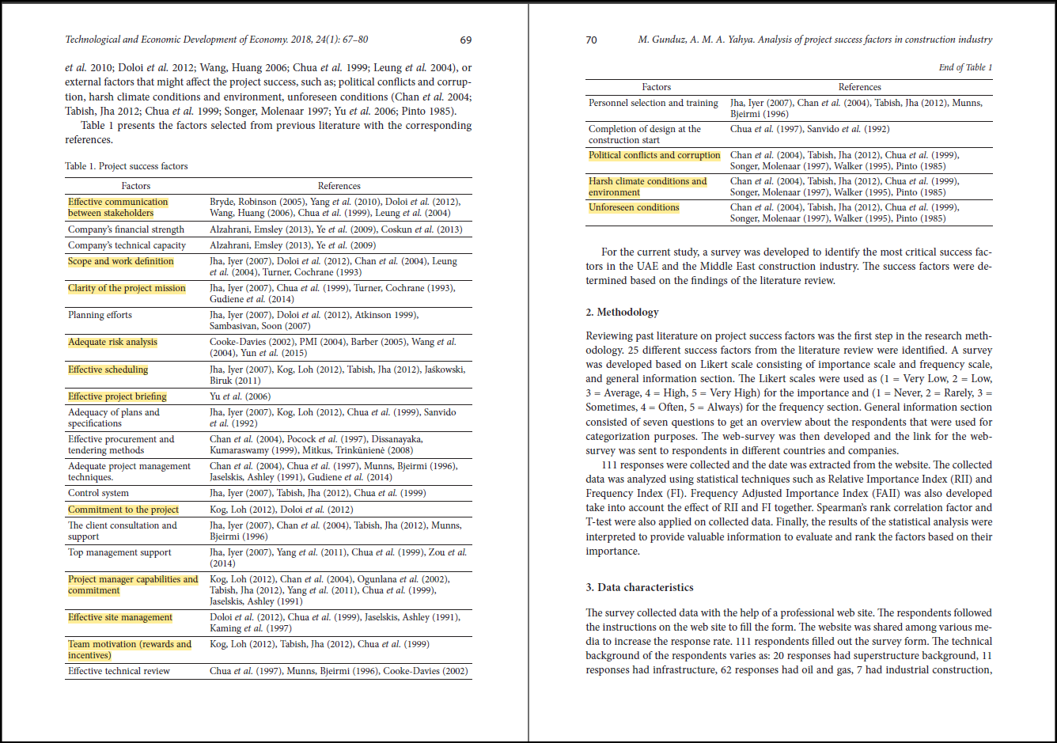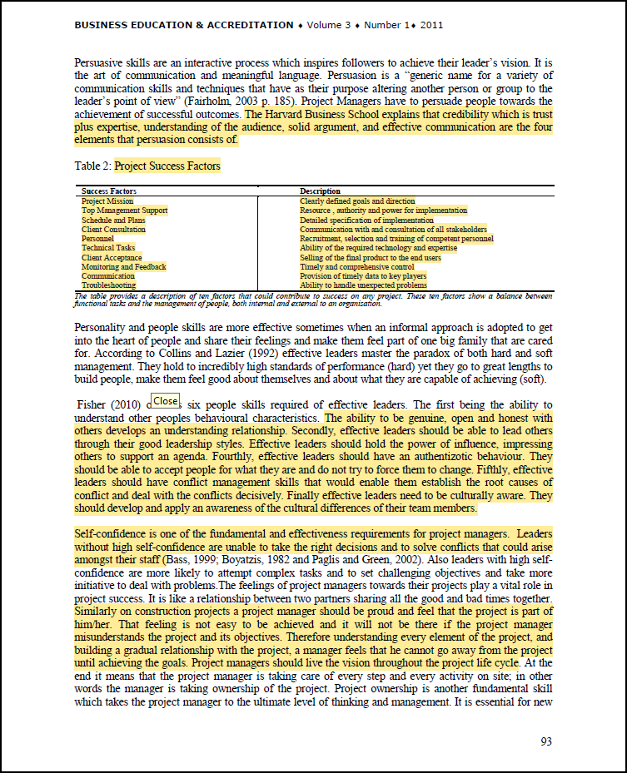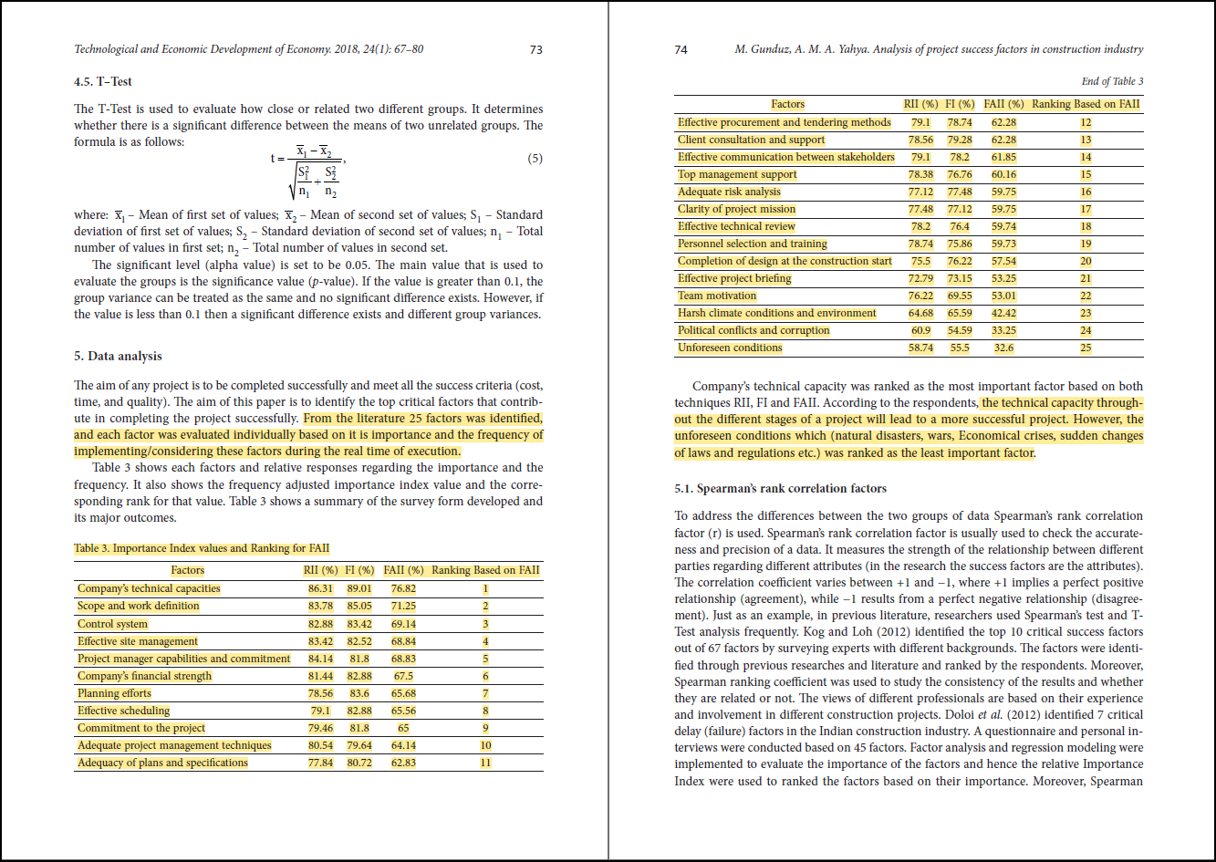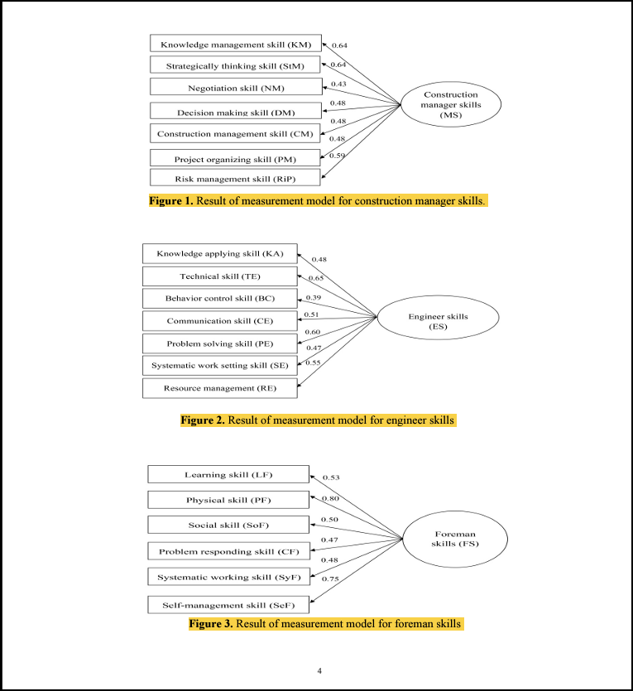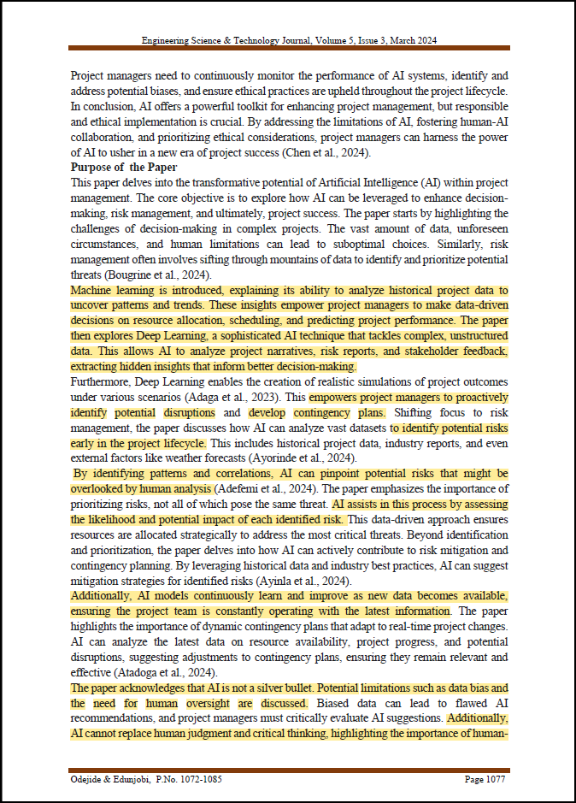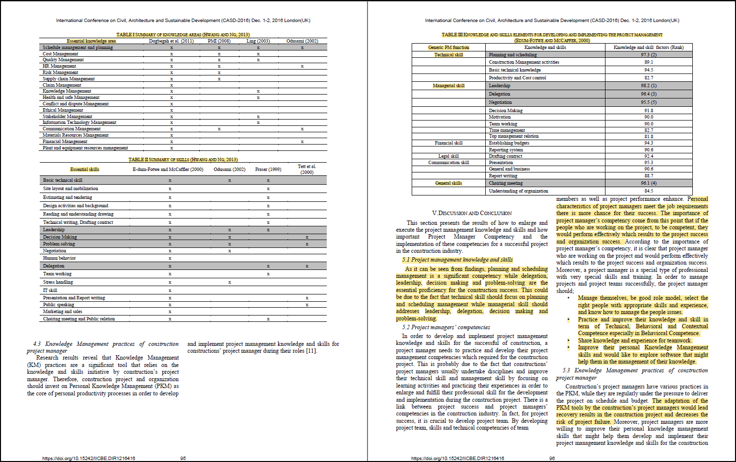

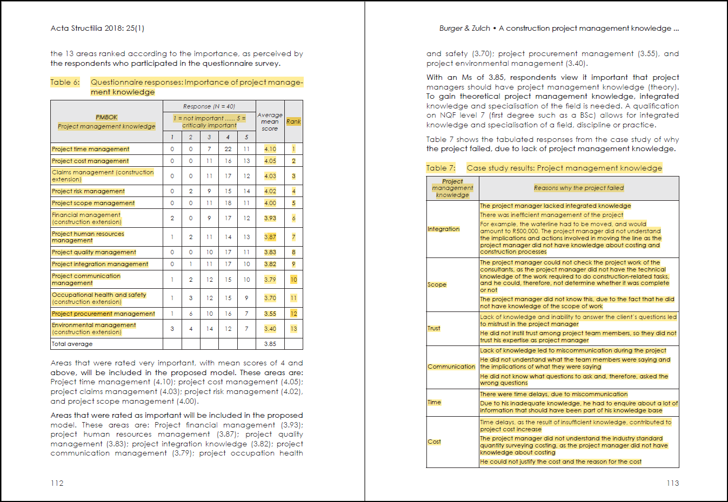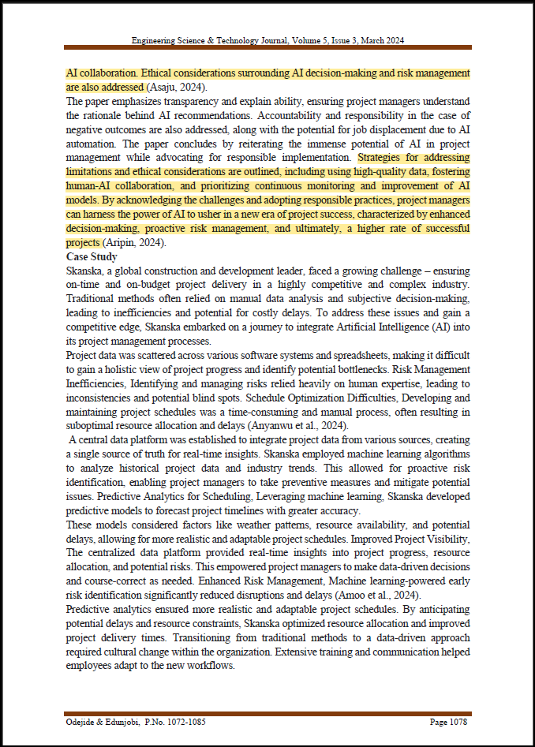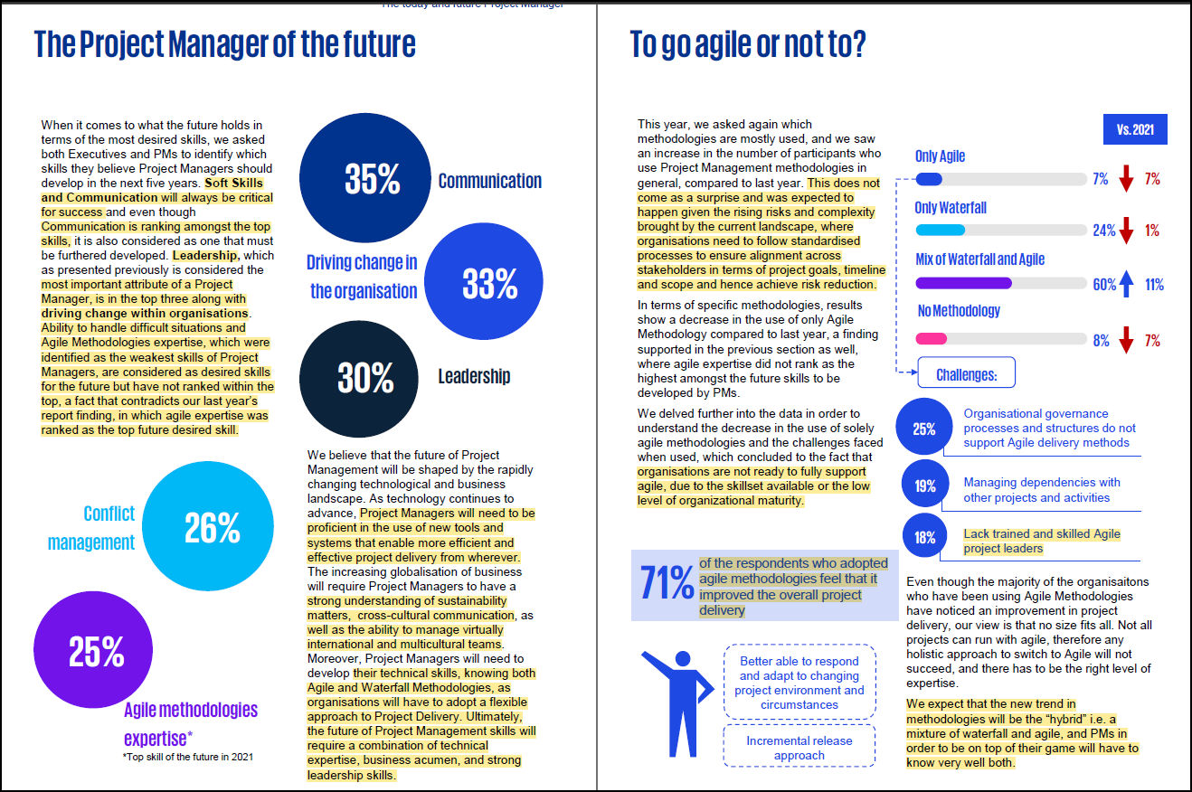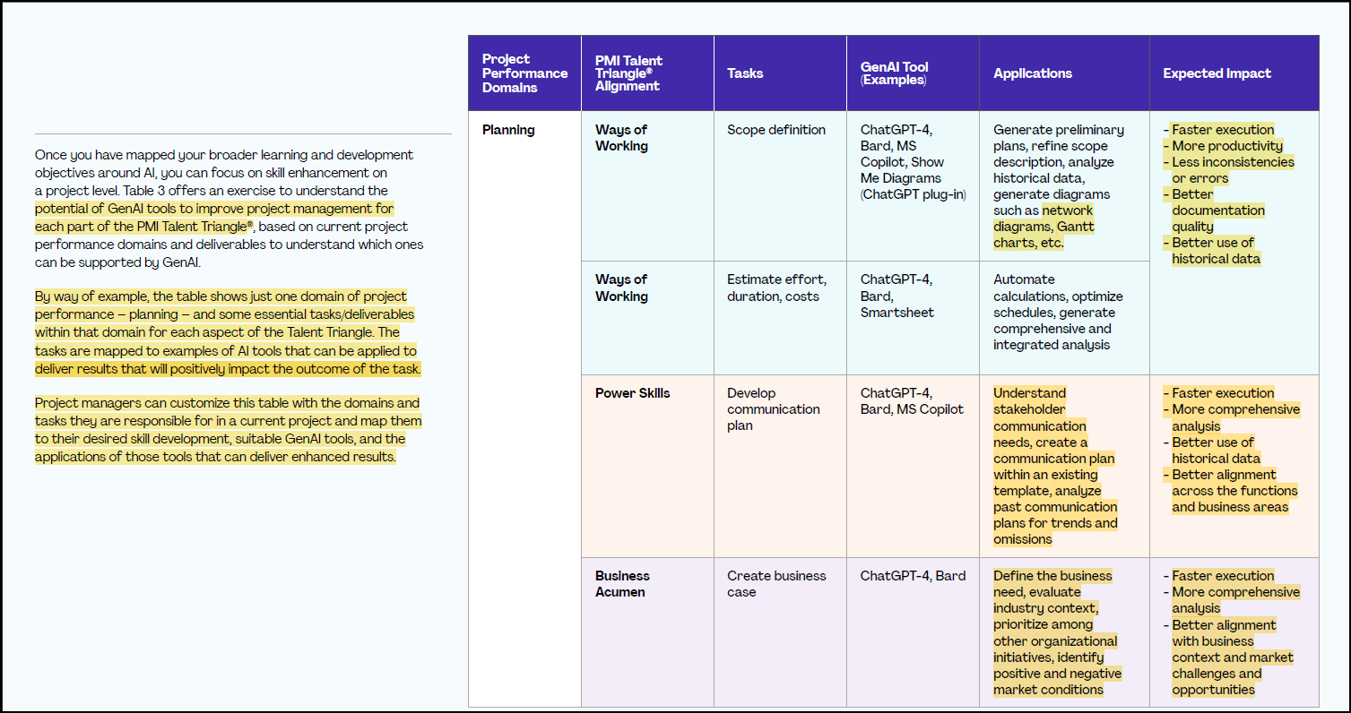

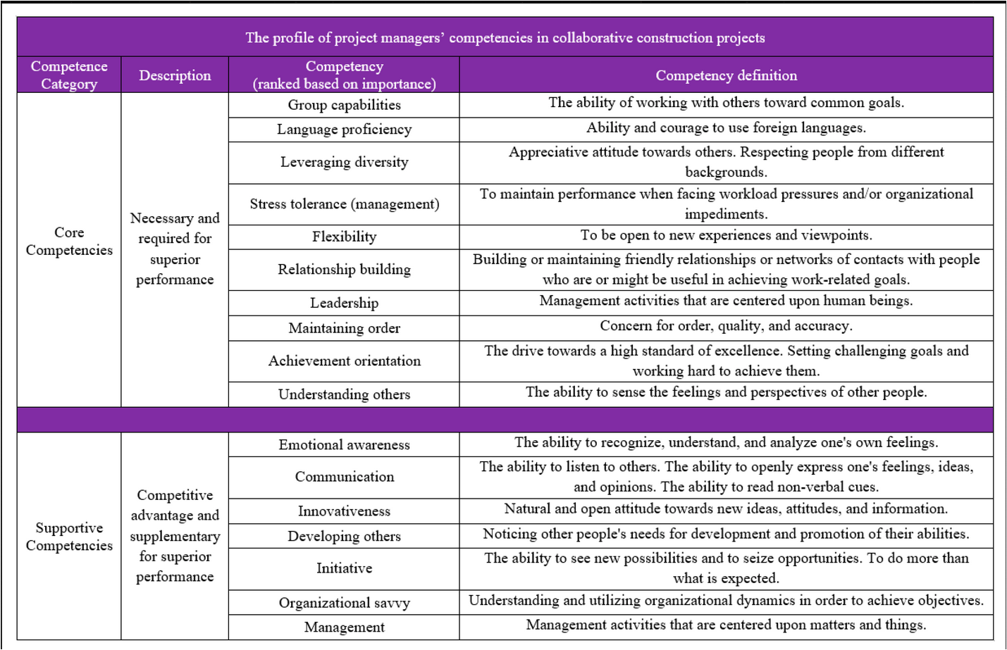

* Discussion

The findings of this research underline the imperative for construction project managers to cultivate a diverse skill set to meet the evolving demands of the industry. The CHPT model, encompassing Conceptual, Human, Political, and technical skills, offers a robust framework for identifying and enhancing these competencies. Notably, the study highlights the increasing relevance of soft skills and the transformative role of Generative AI (GenAI) in project management. While GenAI can significantly enhance efficiency and decision-making, the integration of such technologies necessitates continuous learning and adaptability among project managers. This dual focus on technological proficiency and soft skills is essential for ensuring project success in the dynamic Australian construction sector.

# 5. CONCLUSION

The Australian construction sector is currently at a critical juncture, offering notable challenges and significant opportunities. This study emphasizes the importance of developing essential skills and competencies among construction project managers to navigate this intricate environment effectively. The CHPT model, which covers Conceptual, Human, Political, and technical skills, provides a comprehensive framework for understanding and cultivating the required competencies for successful project management.

Our research highlights the growing importance of soft skills and the transformative influence of technological advancements on the construction industry workforce. The incorporation of Generative AI (GenAI) in project management shows great potential for improving efficiency and effectiveness. Nevertheless, this technological progress requires project managers to acquire new skills and adapt to evolving technologies.

Efficient project management methodologies are vital for the prosperous completion of construction endeavors. By enhancing the crucial skills and competencies of project managers, the Australian construction sector can better equip itself to face forthcoming challenges and ensure project success. This study contributes to the continuous enhancement of project management practices and the reinforcement of the industry's resilience and adaptability.

Insights from recent research, such as the "2022 KPMGxPMI Project Management Survey Report," offer valuable lessons relevant to the Australian setting. The changing role of project managers, the importance of transformation projects, the Agile versus Waterfall methodologies debate, and the critical role of project sponsorship all impact the success of construction projects. Aligning educational and training schemes with current industry requirements will better prepare aspiring construction project managers to overcome challenges and excel in their professions. Ultimately, this study aims to promote the development of capable professionals capable of leading successful projects in the dynamic construction sector.

Survey data from the KPMGxPMI report reveal critical insights about the current state of project manager certifications and skill gaps. Notably, 51% of project managers lack any certification, while 31% hold PMP or other PMI certifications, and 13% possess PRINCE2, MSP, or other Axelos certifications. The survey also identifies the most lacking skills: 30% of respondents reported deficiencies in conflict management, 26% in Agile methodologies expertise, and 25% in driving organizational change. Conversely, the strongest skills among project managers are communication (53%), being a team player (50%), resolving "grey" areas (23%), leadership (22%), and motivating team members (18%).

The Australian construction industry needs to stress effective project management, embrace innovative technologies, and prioritize ESG considerations to tackle significant challenges and exploit vast opportunities. Financial constraints and the pursuit of enhanced performance necessitate a focus on collaboration, risk management, and technology adoption as key drivers for sustainable growth in the long term.

Integrating GenAI into construction project management in Australia brings notable benefits in efficiency, accuracy, and decision-making. However, human supervision remains crucial, particularly for intricate tasks. By combining the strengths of GenAI with the expertise of seasoned project managers, project outcomes can be improved while upholding control and accountability. Continuous evaluation of processes and engagement with stakeholders is essential for the successful integration of AI into our project management structure.

Future studies should aim to gather empirical evidence to analyze the impact of the CHPT model on project performance in construction. The proposed theoretical framework illustrates the intricacy of a project manager's responsibilities and the necessary skills. This framework lays the groundwork for future research, offering a clear path for investigating each skill's influence on project objectives at different phases. Moreover, assessing the effectiveness of the CHPT model in managing stakeholder expectations and identifying the most vital skills for achieving successful project outcomes at varying project stages will be crucial for advancing the field of construction project management.

# 6. REFERENCES

[1] Ahearn, K. K., Ferris, G. R., Hochwarter, W. A., Douglas, C., & Ammeter, A. P. (2004). Leader political skills and team performance. *Journal of Management*.

[2] Block, R. N. (1983). *The politics of projects: A sociological study of project success and failure*.

[3] Burkard, A. W. et al. (2005). Entry-Level Competencies of New Student Affairs Professionals: A Delphi Study. *NASPA Journal*, 42(3), pp. 283–309. doi: 10.2202/1949-6605.1509.

[4] Carmeli, A. (2003). The relationship between emotional intelligence and work attitudes, behavior, and outcomes: An examination among senior managers. *Journal of Managerial Psychology*.

[5] Darnell, P. J. (2005). Developing managerial skills: what do employers value?*Education + Training*.

[6] Drucker, P. F. (1996). *The leader of the future*. Jossey-Bass.

[7] El-Sabaa, S. (2001). Skills of effective project managers: A model. *International Journal of Project Management*.

[8] Ferris, G. R., Treadway, D. C., Perrewe, P. L., Brouer, R. L., Douglas, C., & Lux, S. (2005). Political skill in organizations. *Journal of Management*.

[9] Fisk, E. R. (1997). *Contractor's guide to green building construction: management, project delivery, documentation, and risk reduction*. McGraw-Hill Professional.

[10] Geoghegan, L., & Dulewicz, V. (2008). Do project managers’ leadership competencies contribute to project success?

[11] Gharehbaghi, K. and McManus, K. (2003). Effective construction management. *Leadership and Management in Engineering*, 3, pp. 54-55.

[12] Gido, J., & Clements, J. P. (2012). *Successful Project Management*.

[13] Goodwin, J. (1993). *A guide to managing engineering and architectural design services contracts: What every project manager needs to know*.

[14] Gunduz, M. and Yahya, A. K. H. (2015). Analysis of project success factors in the construction industry. *Technological and Economic Development of Economy*, 24, pp. 67–80.

[15] Katz, R. L. (1974). Skills of an effective administrator. *Harvard Business Review*.

[16] Mchaweh, Abdulrahman, and Eldressi, K. A. Framework for Project Management Office (PMO) as a governance beneficiary and executer in complex organizations.

[17] Mouchi, Glen et al. (2011). The Skill Sets Required for Managing Complex Construction Projects. *Labor: Human Capital eJournal*.

[18] Morrison, J. L., & Brown, R. (2004). Leading and managing construction projects.

[19] Obradović, Montenegro, & Bjelica. Project Management Journal.

[20] Odejide, Edunjobi. (2024). AI in Project Management: Theoretical Models.

[21] Peled, A. (2000). *Interpersonal skills in organizations*. Praeger Publishers.

[22] Peterson, W. (2008). *Project management for construction*. McGraw-Hill Professional.

[23] Prabhakar, G. P. (2005). Leadership and performance in construction projects. *Leadership & Organization Development Journal*.

[24] Project Managers’ Competencies- Survey of perspective from project manager in southeast Queensland

[25] Rahim, M. A. (1992). Toward a theory of managing organizational conflict. *International Journal of Conflict Management*.

[26] Rezende, L. B. D., & Blackwell, P. (2019). *Iberoamerican Journal of Project Management*.

[27] Rezende, L. B. D., & Blackwell, P. (2019). Project management competency framework.

[28] Sina Moradi, K., Kahkonen, K., & Aaltonen, K. (2020). Project Managers' Competencies in Collaborative Construction Projects.

[29] Standards Australia. (2009). Project management—Project risk management. *Standards Australia*.

[30] Trebilcock, R. (2007). *Construction management strategies: a theory of construction management*.

[31] Title: Key Factors Employers Look for In Hiring Construction Managers.

[32] Title: Relationships of construction project manager, engineer, and foreman skills.

[33] Ekwuno, A. O. (2022). Key Factors Employers Look for In Hiring Construction Managers for Public and Private Construction Projects. *International Journal of Scientific Research in Science and Technology*.

[34] Jaser Mahasneh, W., & Thabet, W. Rethinking Construction Curriculum: A Descriptive Cause Analysis.

[35] Achara Khamaksorn. Project Management Knowledge and Skills for the Construction Industry.

[36] F. Edum-Fotwe, R. McCaer. (2000). *International Journal of Project Management*, 18, pp. 111-124.